EXPERIMENT 12
CURSORS
Aim:
- Create a table with attributes students and marks.
- Insert values into the table.
- Create a procedure, and fetch the marks of given id using a cursor.
- Create a procedure, and fetch the highest marks using a cursor.
QUERIES:

Create a table with attributes students and marks.
Insert values into the table.
Create a procedure, and fetch the marks of given id using a cursor.
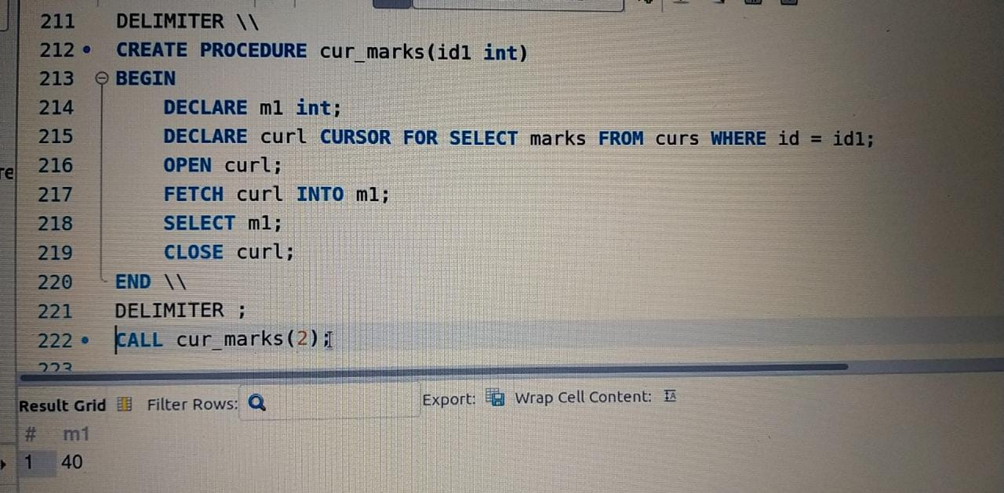

Create a procedure, and fetch the highest marks using a cursor.
